**Welcome to**

Sweden Pro Rekordspelen

2025

**26/9 – 28/9 in Helsingborg**

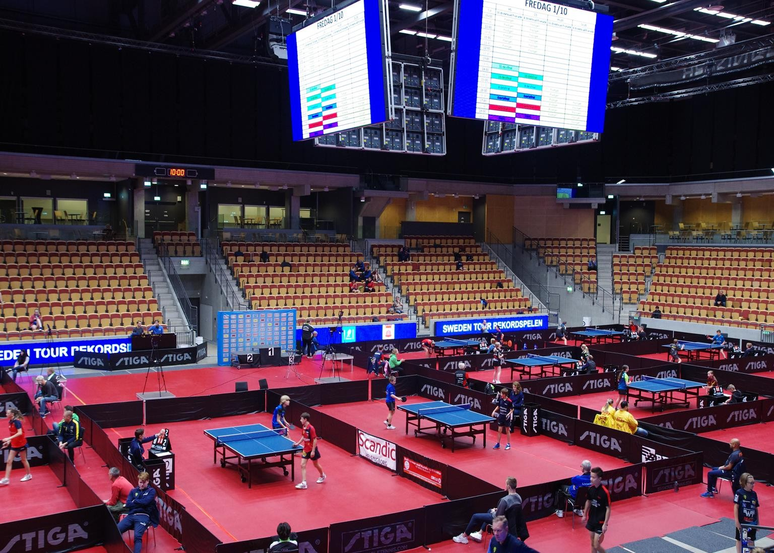

**Sweden Pro Rekordspelen is one of the biggest tournaments in Sweden, played in the fantastic Helsingborg Arena, host of the European Veteran Championships 2017, European Para Championships 2019 and Youth World Championships 2024!**

**Helsingborg, with its close location to the boarder of Denmark, gives the tournament an international touch with a tradition of bringing national team players from not only Sweden but also Denmark, Norway and Iceland, amongst others.**

**The Swedish Table Tennis Federation and host club BTK Rekord wishes you the warmest of welcomes to this year’s edition of**

**Sweden Pro Rekordspelen!**

**Events:**

Men’s Open Men’s U21 Men’s U19 Boys 16

Boys 14

Boys 13

Boys 12

Women’s Open Women’s U21 Women’s U19 Girls 16

Girls 14

Girls 13

Girls 12

(born 2005 or younger) (born 2007 or younger) (born 2009 or younger) (born 2011 or younger) (born 2012 or younger) (born 2013 or younger)

Group Group Group Group Group Knock-Out Group

Max 2 249 (level-based category with mixed gender and age) Knock-Out

**Accomodation:**

**Hotel:** Scandic Helsingborg Nord*** (free parking and wi-fi).   
Address: Florettgatan 41, Helsingborg.

**Meals:** Breakfast is included. It is possible to order lunch, which is served in the competition venue. Dinner is available to eat at the hotel.

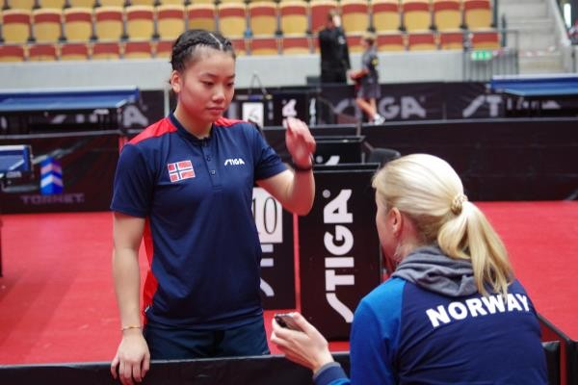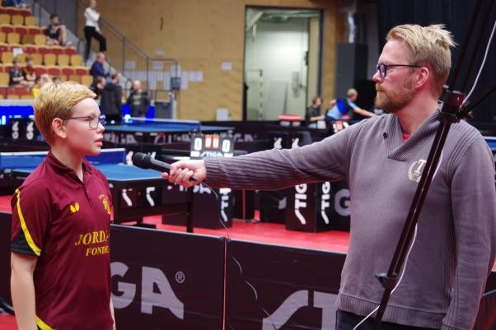

# Costs:

**Accomodation:**

85 €/night in single room. 100 €/night in twin room. 120 €/night in triple room. 150 €/night in quadruple room.

**Lunch:**

12 €/lunch

## Entry Fees:

|  |  |
| --- | --- |
| Men’s and Women’s Open | 50 € |
| Men’s and Women’s U20 | 30 € |
| Men’s and Women’s U18 | 30 € |
| Boys and Girls 16 | 30 € |
| Boys and Girls 14 | 25 € |
| Boys and Girls 13 | 20 € |
| Boys and Girls 12 | 25 € |
| Max 2 249 | 25 € |

# Registration:

The registration is open until 7th of September 2025.

Send your registration to: [bordtennis.rekord@gmail.com](mailto:bordtennis.rekord@gmail.com)

Please provide **names**, **events**, **lunch**, and if you would like to book the **hotel** offered by us.

Your registration is completed when confirmed.

# Prizes:

In Men’s and Women’s Open, U21 and U19: Total price pool 4 500 €.

In other categories, prizes will be given from our sponsors.

# Information:

## Tournament Office: Social media:

Panagiotis Månsson, bordtennis.rekord@gmail.com

Facebook: BTK Rekord

Instagram: BTKRekord

YouTube: BTKRekord1 (livestreams available)

# Former winners (Men’s and Women’s open):

**2024:** Antoine Doyen (POR)

**2023**: Tom Jarvis (ENG)

**2022**: Elias Ranefur (SWE)

**2021**: Mehdi Boulossa (FRA/ALG) **2020**: Ibrahima Diaw (SEN)

Li Fen (SWE)

Li Fen (SWE)

Christina Källberg (SWE) Li Fen (SWE)

Linda Bergström (SWE)

**Welcome to Helsingborg 26/9 – 28/9 2025**

